**Project Design Phase-II**

**Data Flow Diagram & User Stories**

|  |  |
| --- | --- |
| Date | 18 March 2025 |
| Team ID | SWTID1743689974 |
| Project Name | Book Store |
| Maximum Marks | 4 Marks |

**Data Flow Diagrams:**

A Data Flow Diagram (DFD) is a traditional visual representation of the information flows within a system. A neat and clear DFD can depict the right amount of the system requirement graphically. It shows how data enters and leaves the system, what changes the information, and where data is stored.

Example: DFD Level 0 (Industry Standard)

**Example:** [**(Simplified)**](https://developer.ibm.com/patterns/visualize-unstructured-text/)

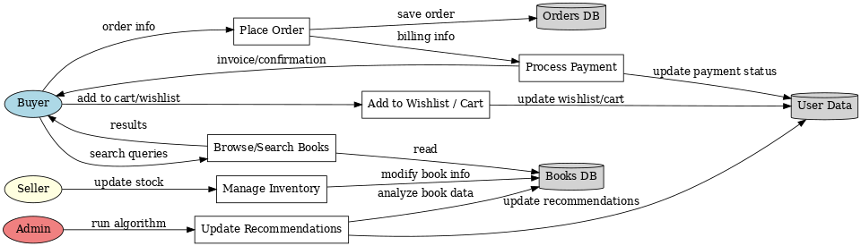

**Flow Sequence:**



1. User configures credentials for the Watson NLU service and starts the app.
2. User selects the data file to process and load.
3. Apache Tika (within cloud) extracts text from the file.
4. Extracted text is sent to Watson Natural Language Understanding.
5. Enriched text is visualized using the D3.js library in the UI.

**User Stories**

|  |  |  |  |  |  |  |
| --- | --- | --- | --- | --- | --- | --- |
| **User Type** | **Functional Requirement (Epic)** | **User Story Number** | **User Story / Task** | **Acceptance Criteria** | **Priority** | **Release** |
| Buyer | Registration | USN-1 | As a buyer, I can register and log in using Firebase auth (email/password or Google). | I can access my account/dashboard after successful login. | High | Sprint-1 |
| Buyer | Browse & Sort Books | USN-2 | As a buyer, I can filter books by genres I like. | I can select genres and see sorted books by genre. | High | Sprint-1 |
| Buyer | Recommendations | USN-3 | As a buyer, I can view a recommended books section based on my preferences. | Recommendations display correctly based on interaction/genre. | Medium | Sprint-2 |
| Buyer | Wishlist | USN-4 | As a buyer, I can add books to a wishlist to save them for later. | Books are saved in wishlist and persist after reload. | High | Sprint-2 |
| Buyer | Cart | USN-5 | As a buyer, I can add books to the cart and proceed to checkout. | I can add/remove items from cart and see the cart summary. | High | Sprint-2 |
| Buyer | News | USN-6 | As a buyer, I can see a news section about new arrivals and author updates. | News section displays book-related content. | Low | Sprint-3 |
| Buyer | Top Sellers | USN-7 | As a buyer, I can view a Top Sellers section showcasing most popular books. | Top sellers are displayed based on sales data. | Medium | Sprint-2 |
| Admin | Registration & Auth | USN-8 | As a seller, I can sign up/login using Firebase and manage my listed books. | Seller dashboard becomes available upon login. | High | Sprint-1 |
| Admin | Manage Book Listings | USN-9 | As a seller, I can add, edit, or delete book listings. | CRUD operations work correctly on seller's own books. | High | Sprint-1 |
| Admin | View Sales Metrics | USN-10 | As a seller, I can view sales and performance analytics for my books. | Stats for sales, clicks, etc., appear in seller dashboard. | Medium | Sprint-3 |
| Admin | Manage Users | USN-11 | As an admin, I can view and manage buyer and seller accounts. | Admin dashboard lists all users with manage options. | High | Sprint-1 |
| Admin | Moderate Content | USN-12 | As an admin, I can review and remove inappropriate listings or reviews. | Admin can remove content and see moderation history. | Medium | Sprint-2 |
| Admin | System Dashboard | USN-13 | As an admin, I can view overall platform stats including user activity and sales. | Admin dashboard shows platform-wide metrics. | Medium | Sprint-3 |